Image and Video Processing on YOLO11
- Label your images on MakeSense (https://www.makesense.ai/)

- Split and apply data augmentation on Roboflow (https://roboflow.com/) - Sign in by using email

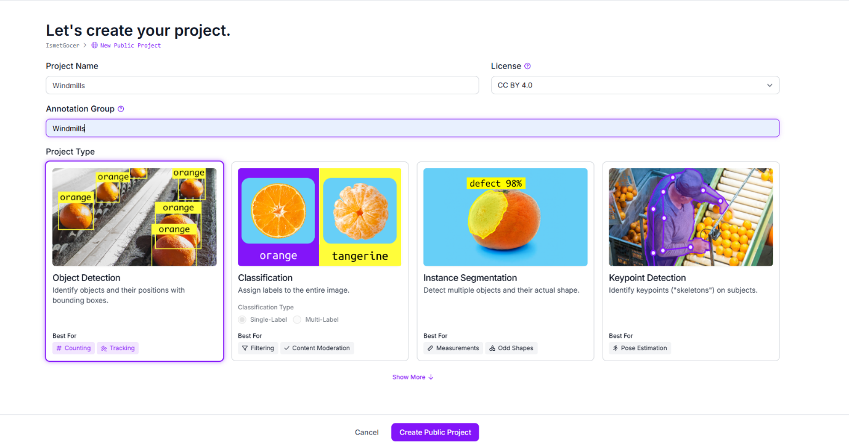
  - Write project name and annotation group, choose project type.

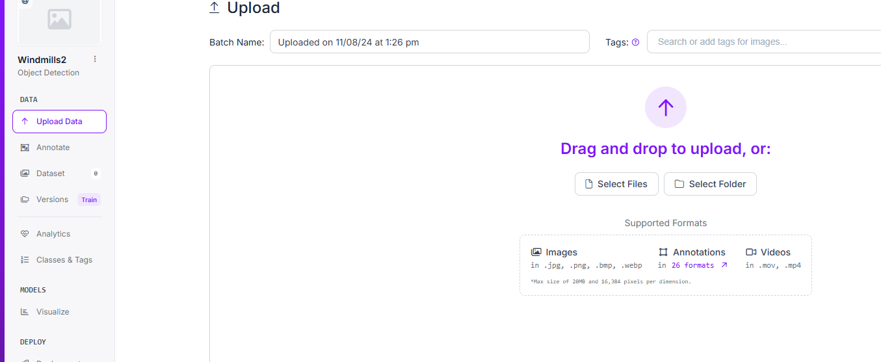
  - Upload images and annotations together (drag and drop)
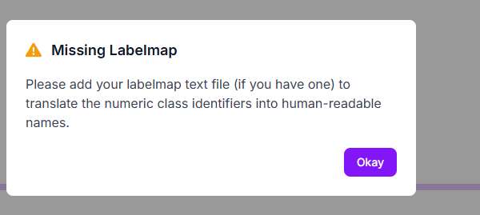
No worries, say Okay.

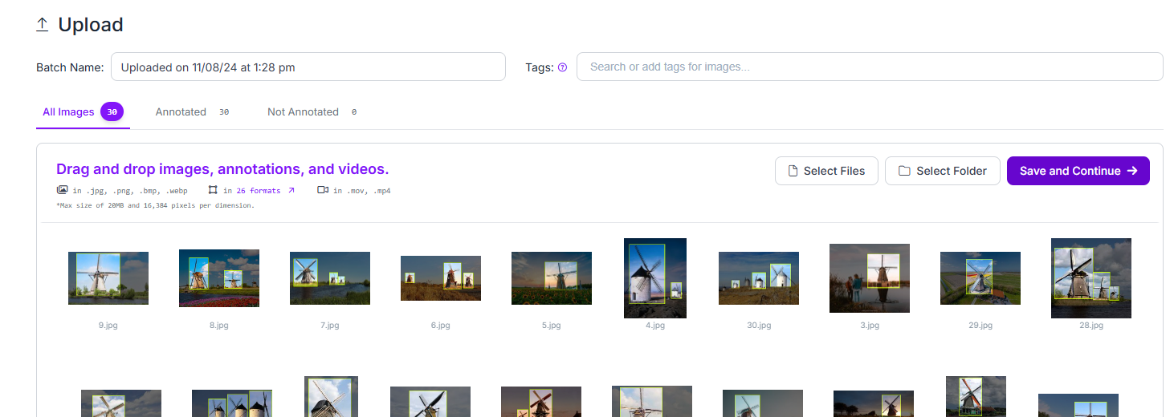

  - Choose split ratio
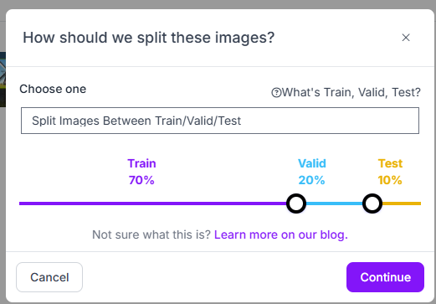

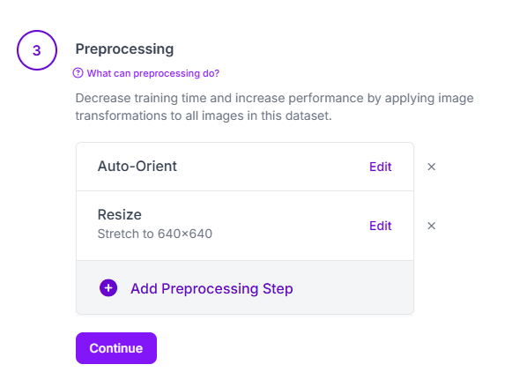

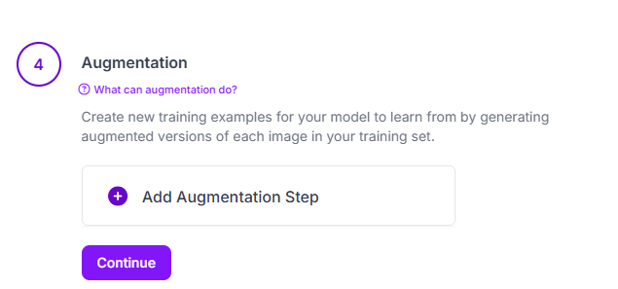

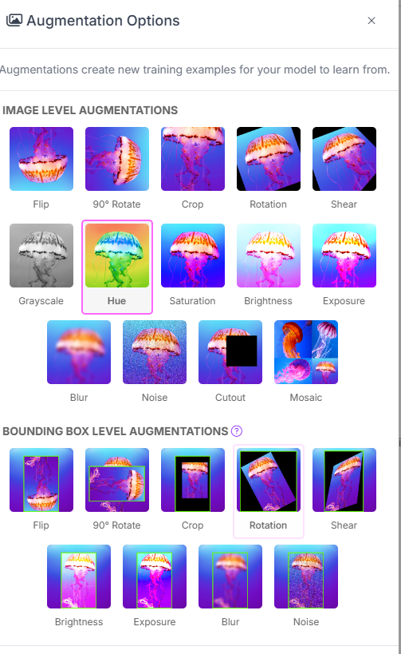
  - Choose

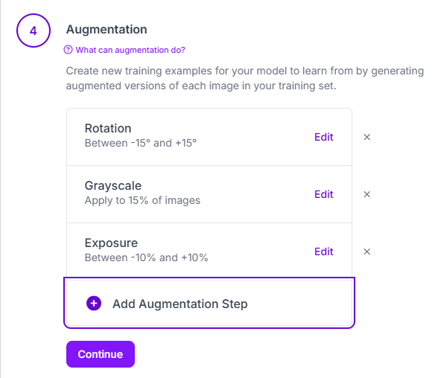

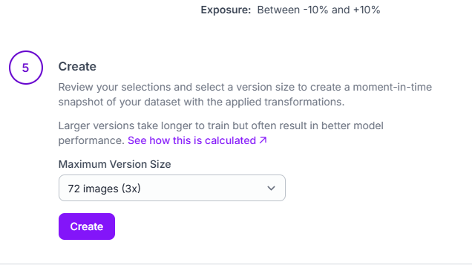

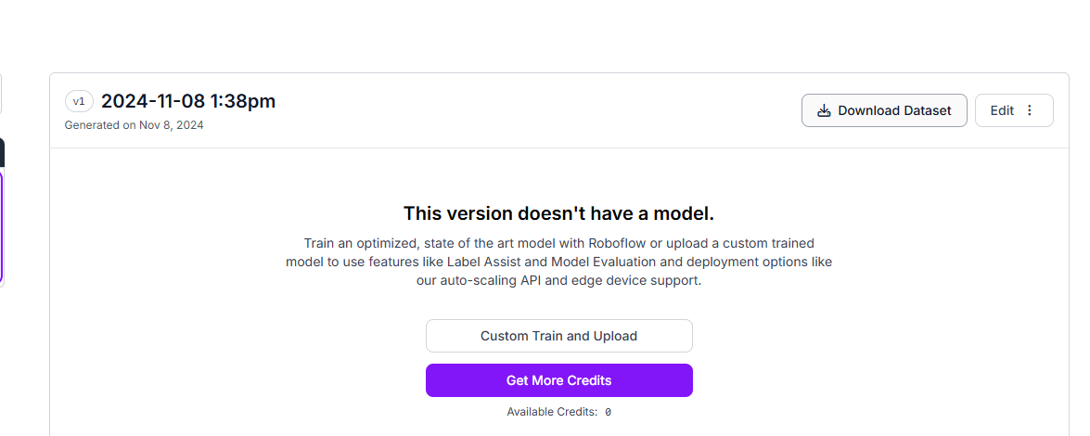

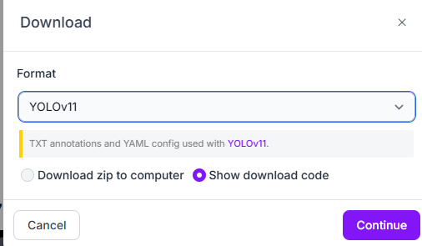

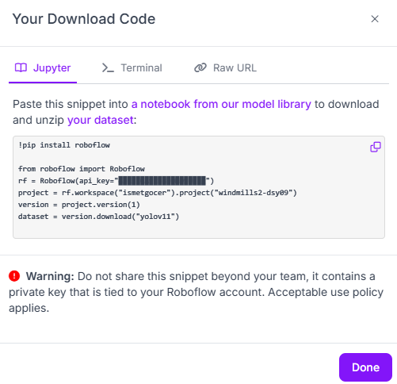
n.
Copy this code and click on “a notebook …”

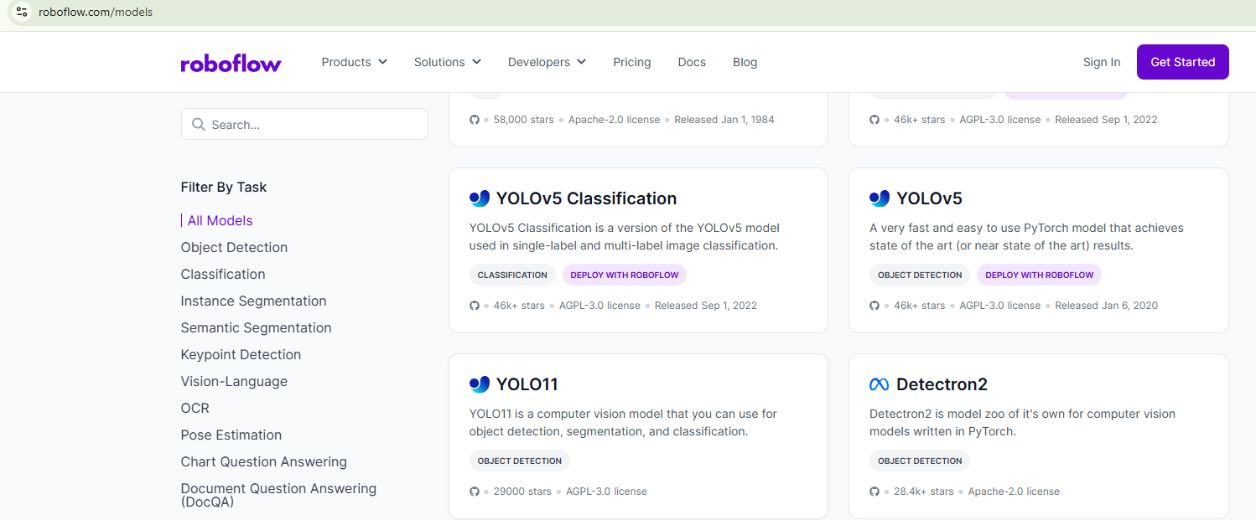

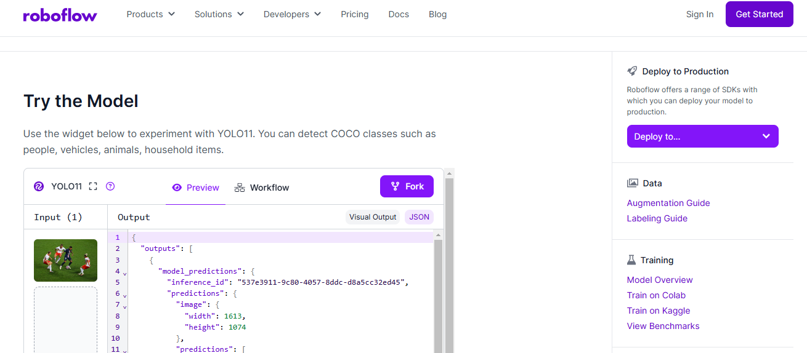
m.

- Pass to YOLO11. RUN sequent;
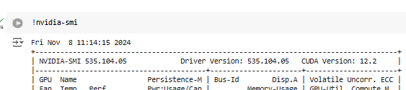

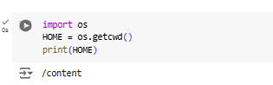

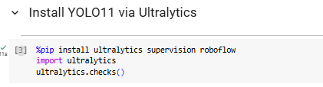

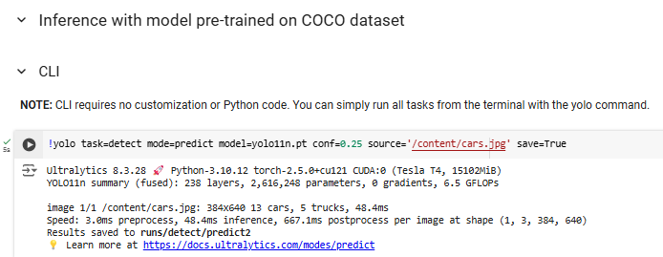

We can change this image path and proceed our images.

Results in here….

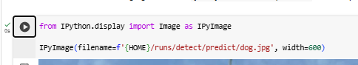

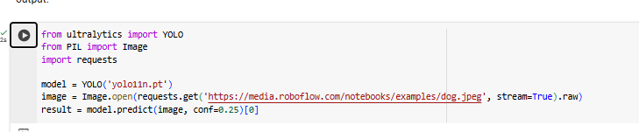

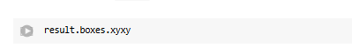

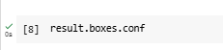

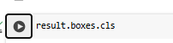

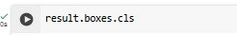

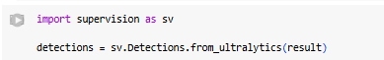

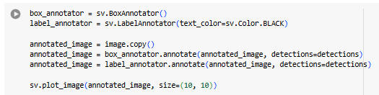

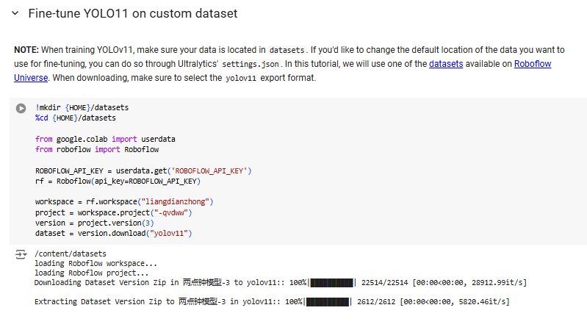

We will integrate our data into YOLO11.
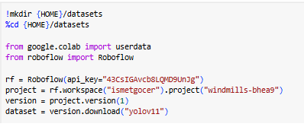
For this, we should copy and paste our Api_Key code block here.

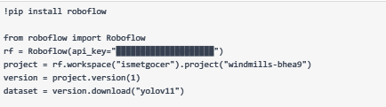
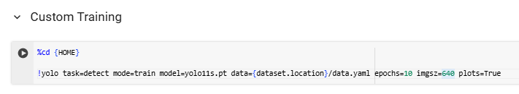
  - We can customize training section based on our image sizes (or you can pass directly).

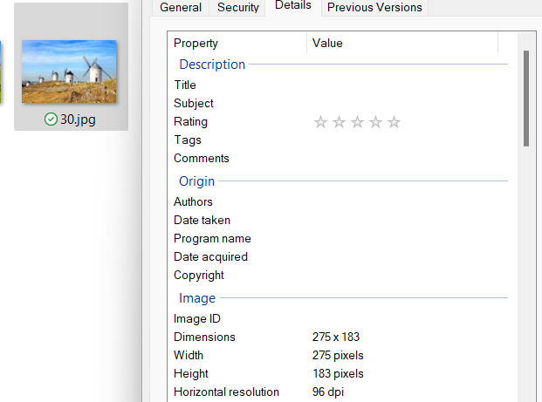
I wrote 275 as image size since my images in 275 x 275

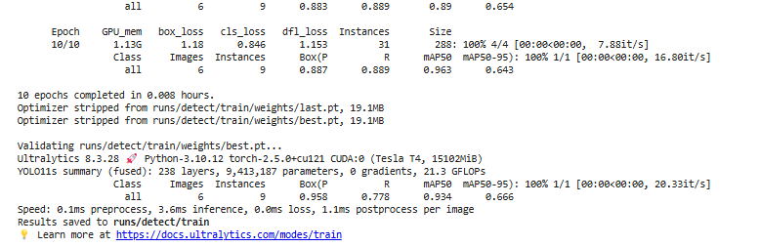
  - For see eval metrices we can run following codes or look at runs/detect/train

Since mAP50 = 0.96, model is successful.
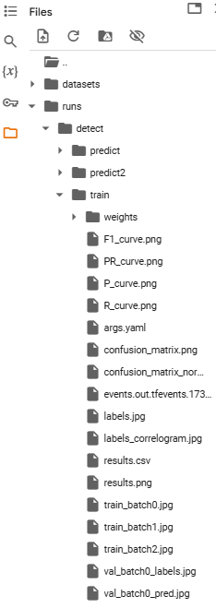

We trained our YOLO11 model on our data set. From now we will get predictions on images and video.

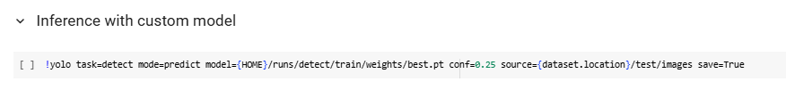

We should write our image path here

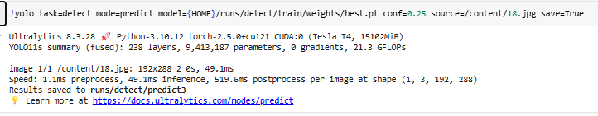

We can see result here

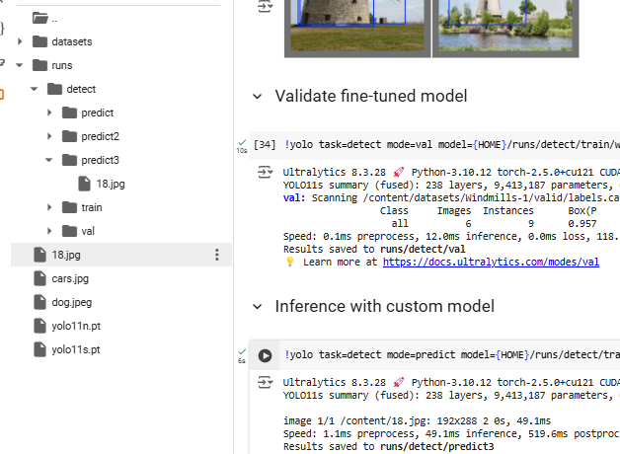
r.

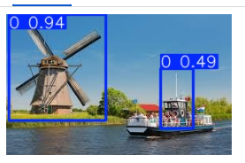
s.
This annotation and score produced by YOLO11

t. We can upload a video

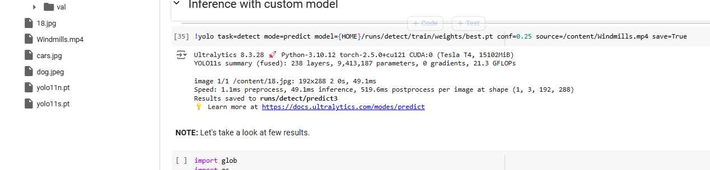

u.

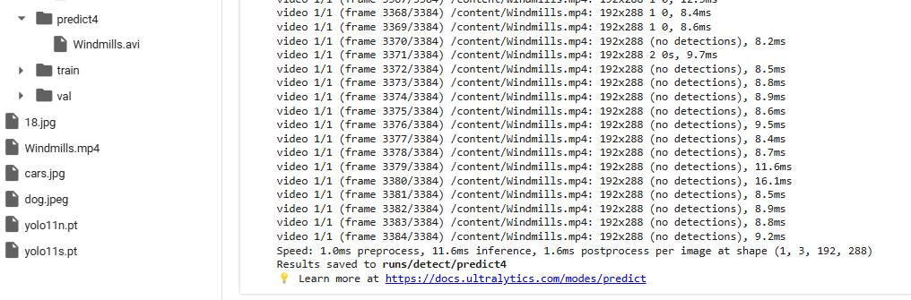
u. Result in here

Download this video and see results…

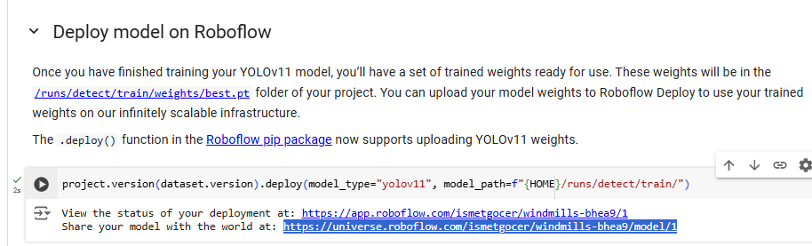
v. We can deploy our results on Robofow.

